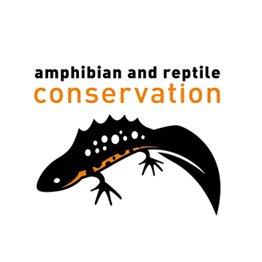

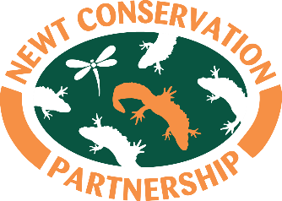
Application for:  Berkshire Project Officer | CLOSING:  Friday 19th August (12 noon)
Please complete & email to  Catherine Turner  cturner@newtpartnership.org.uk | or send hard copy to:  Catherine Turner,  Freshwater Habitats Trust  1st floor, Bury Knowle House  North Place, Headington, Oxford, OX3 9HY

1 PERSONAL DETAILS
SURNAME
FIRST NAMES

ADDRESS

POSTCODE

TELEPHONE - Daytime
TELEPHONE – Home/mobile

EMAIL

2 PRESENT OR MOST RECENT EMPLOYMENT
EMPLOYER’S NAME & ADDRESS
POST HELD
DATES OF JOINING & LEAVING
PERIOD OF NOTICE REQUIRED
Please give a brief description of the duties and responsibilities you carry/carried out:

3 PREVIOUS EMPLOYMENT
DATES  (From…To) | EMPLOYER NAME AND ADDRESS | Please give a brief description of the position, duties and responsibilities and your reason for leaving

4 TRAINING, QUALIFICATIONS AND OTHER LEARNING
Please give details of your academic and professional qualifications, and any other qualifications you have gained, including specialist in-house training, short courses etc. and any course(s) you are currently undertaking.

BRIEF DESCRIPTION OF COURSE AND DETAILS OF AWARDING BODY | DATES

5 DRIVING LICENCE
Do you have a full, current, driving license? | YES/NO
Do you have a car that you can use for business? | YES/NO

6 CRIMINAL RECORD
Please give details of any unspent criminal offence in accordance with the Rehabilitation of Offenders (Exceptions) Order 1975 and/or (Northern Ireland) 1979.

7 REFERENCES
Please give details of two people, not related to you, who we may ask for references as to your suitability for the post. The first should be your current or most recent employer. The second should be someone able to comment on your work abilities.

NAME
POSITION
ADDRESS

POSTCODE
TELEPHONE

email
May we contact this person before your interview? | YES/NO
NAME
POSITION
ADDRESS

POSTCODE
TELEPHONE
email

May we contact this person before your interview? | YES/NO

8 WORK PERMIT
Do you need a work permit to work in the UK?  (If yes please confirm that you have the legal right to work in the UK) | YES/NO  YES/NO

9 ADDITIONAL INFORMATION
Before completing this section, please read the enclosed outline Job Description and Person Specification carefully and demonstrate how you meet the requirements by giving relevant details of your experience, skills and knowledge gained in employment and elsewhere. We would also like to know what you can bring to Freshwater Habitats Trust.

I CONFIRM THAT TO THE BEST OF MY KNOWLEDGE AND BELIEF THE INFORMATION GIVEN ON THIS FORM IS CORRECT
SIGNATURE  If you return this form by email, this will be taken as signing the document. | DATE

To help us monitor our recruitment advertising, please tell us where you saw this post:

