Tubular Water-dropwort (Oenanthe fistulosa)
METHOD
Aims: To find out if Tubular Water-dropwort is i) present in the pond, ii) get an approximate idea of its location and abundance in the pond, iii) collect physical data about the pond that can be used to assess the reasons for any change recorded on future visits.
- Equipment: It’s helpful to take a camera (e.g. mobile phone camera) to take confirmatory photos of Tubular Water-dropwort, to take photos of your survey pond for the record, and to take a photograph of your sketch maps if you don’t have access to a scanner – alternatively you can give your survey forms to your regional officer.
- Survey timing: Tubular Water-dropwort is quite a late-growing plant and is best surveyed between July and September.
- Where to look: Tubular Water-dropwort typically grows in the pond’s drawdown zone – the area that is wet in winter, but progressively dries out in summer. Plants can be found growing amongst long or short grass and other wetland plants, or along muddy margins and in shallow water poached by animal’s hooves. Search for it across all of the pond’s dry marginal areas and in shallow water. For a temporary pond, without water in, the drawdown zone is 100% of the pond area.
- Survey the pond: The pond will have a previous record for Tubular Water-dropwort, although the plant may not have been recorded since the 1980s. Search the pond margins and shallow edges for Tubular Water-dropwort plants, and if found, estimate the number of plants (see below). Print a map to show the location of Tubular Water-dropwort within the pond. This may help you and others in the future to search the same area. Fill out the pond habitat survey form for each pond surveyed – this is critical for our project student who is investigating differences between Tubular Water-dropwort populations.
- How to estimate abundance: If Tubular Water-dropwort plants are found in the pond, make an estimate of the number of plants present, and record the results as an abundance category (over page). It can be hard to count the number of plants, especially if they are small, closely inter-growing or very numerous. The best approach is to count the plants in a small area (e.g. 10 cm² or 1 m²), and multiply this by the area in which Tubular Water-dropwort plants are found. If Tubular Water-dropwort occurs in different areas or habitats in the pond, make separate calculations for each area, and sum them to give a total (see table over page). Note, we only need the overall total for the pond.

If Tubular Water-dropwort is not found at the pond, please record this, and continue to fill out the environmental sheet. The findings will help identify reasons for the plant’s absence from the pond.
- Check other ponds and pools in the surrounds: Finding out if Tubular Water-dropwort occurs in other nearby ponds helps us to understand if the species is part of a larger population, which may be important for its survival. We would like you to visit as many ponds on each site as possible. If Tubular Water-Dropwort is present or absent fill in this form for those ponds too.

It will be helpful to revisit these other ponds in future years. So, to ensure they can be found again by yourself or others please (a) provide an accurate grid reference and/or mark the locations on your PondNet base map, or (b) sketch a map of location of ponds, and (c) take photos. Then, upload the maps and photos to the website.
What it looks like: Tubular Water-dropwort is a very variable species: it often occurs as small low-growing plants only a few cm high, with a rather cow-parsley-like basal leaf (basal leaves grow at the bottom of the stem) and may also have finely divided submerged leaves (see photo). It is easier to identify and record abundance once the plants reach maturity. The characteristic stem and stem leaves of Tubular Water-dropwort (see photo), typically develop when the plants are older. Mature, flowering, plants can be surprisingly tall: over 1m in height. Where they grow in amongst other tall wetland species, their stems are sometimes lax and scrambling, and they often fall over as the stems are quite weak. Later in the season, the flowers develop distinctive rounded fruiting heads.
We have produced a “Species Information Sheet” and “How to . . .” identification guide if you need some more hints and tips to recognise Tubular Water-dropwort from the other water-dropworts www.freshwaterhabitats.org.uk/projects/pondnet.
Once completed, enter your results online: www.freshwaterhabitats.org.uk/projects/waternet, or give your recording forms and maps to your regional project officer and we can enter data for you.
RARE SPECIES RECORDING FORM (PAGE 1 of 4)
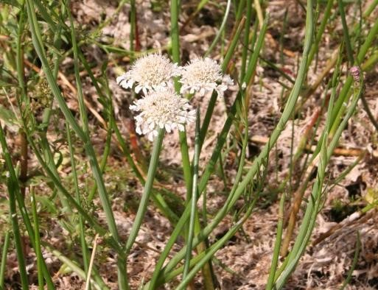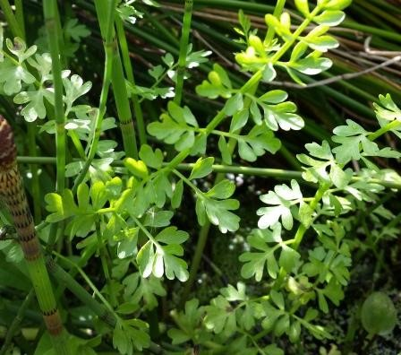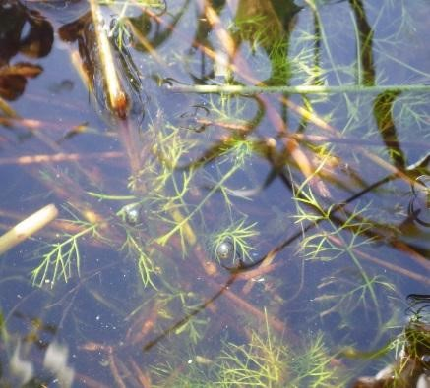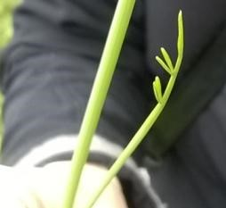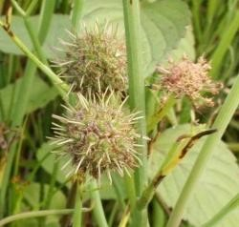
Tubular Water-dropwort: (a) submerged leaves, (b) basal leaves and (c) flowering stem - the easiest stage to identify, with characteristic stem leaf (ci) and globular fruiting heads (cii).

(
ci
)

(
cii
)

(
a

)

(
b
)

(
c
)

Tubular Water-dropwort (Oenanthe fistulosa)

RARE SPECIES RECORDING FORM (PAGE 2 of 4)

Your name |  |  |  | Date
Square: 4 figure grid ref  e.g. SP1243 (see your map) |  |  | Pond: 8 figure grid ref  e.g. SP 1235 4325 (see your map)
Focal Pond name
(if known)
Determiner name (optional - if someone confirms the identity of the species you’ve recorded) |  |  | Voucher material (optional - comment if you’ve taken a photo to confirm identification)

Number of Tubular Water-dropwort in the pond
Record the number of Tubular Water-dropwort plants found in the pond using the following categories:
1, 2-5, 6-10, 11-20, 21-50, 51-100, 101-200, 201-500, 501-1000, 1000-2000, 2000+. If there are many plants, count the number in a small area and multiply up. We’ve put a table below to help you keep track and make notes, but for the analysis we only need a total.
If you find Tubular Water-dropwort please take a confirmatory photo, especially if it’s the first time the pond has been surveyed for
PondNet. You can also take a photo of your pond or your maps (or scan them if you have a scanner) and upload them with the record.
Pond habitat type or areas where the plant is found (list): use this table to help with your number calculations, and so you / others can re-find plants | Number of plants
1.
2.
3.
4.
5.
6.
Total number of Tubular Water-dropwort plants (category)
Tubular Water-dropwort looked for, but not found: (tick box if none found)
Note if you don’t find evidence of Tubular Water-dropwort at the pond, this is an important result so please still enter these findings online

Sketch map:
1. Make a sketch map of your pond (or download the image from google maps) and draw on the location of Tubular Water-dropwort: use shading if they covered a broad area, or x marks the spot if there are just a few plants. We are asking you to count the number of flower spikes, but you can also indicate on the map the extent of the non-flowering plants, if they are present.
2. Mark on the extent of the drawdown zone (the distance between the maximum winter water line and the lowest summer level). In temporary ponds the drawdown zone will cover 100% of the pond area.

Tubular Water-dropwort (Oenanthe fistulosa)

RARE SPECIES RECORDING FORM (PAGE 3 of 4)

PondNet

Please complete a POND HABITAT SURVEY sheet at each pond surveyed.

This is a really important part of the survey at your pond. Please complete this form whether Tubular Water-dropwort is present or absent. Each variable provides information known to be linked to pond quality and community type, and can be used to investigate reasons for change in Tubular Water-dropwort occurrence. Go to: www.freshwaterhabitats.org.uk/projects/pondnet/survey-options/habitats for survey guides and more information.

 |  |  | Is this a new pond? i.e. is pond less than 10 yrs old (choose one option - yes, no, unknown) |  |  |  |  |  |  |  |  |  |  |  |  |  |  | What year was the pond created?  (unknown, exact date or nearest decade)
Pond area: |  |  | Note: This is the surface area of the pond when the water is at its highest level (usually in early spring). It will probably not be the current water level of the pond. The high water level line should be evident from wetland vegetation like rushes at the pond’s outer edge. Measure by pacing (single pace = 0.8-1m) or use online maps.
m²
Pond dries?: choose one option 1 = never dries, 2 = rarely dries, 3 = sometimes dries, 4 = dries annually
 |  |  | Never; Rarely: no more than 2 years in 10, or only in drought; Sometimes: dries between 3 years in 10 to most years; Annually: deduce pond permanence from local knowledge (e.g. landowner) and personal judgement e.g. water level at the time of the survey. Ponds that dry out annually usually have a hard base.
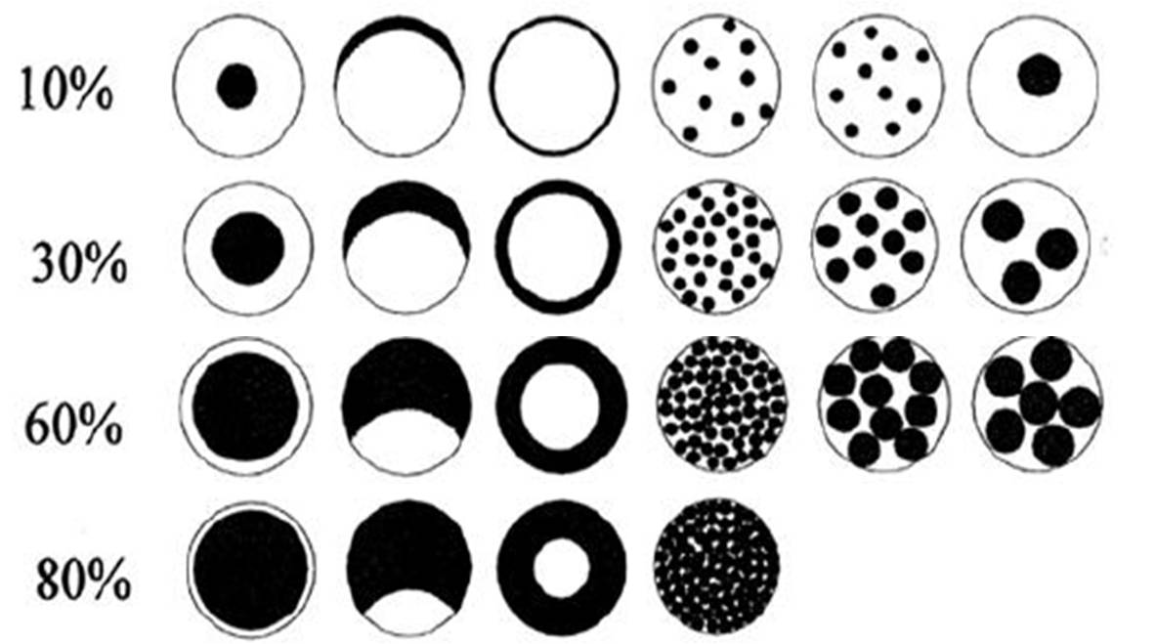
Overhanging trees & shrubs: This is an estimate of how much of the pond is directly overhung by trees and shrubs, i.e. that would be shaded if the sun was overhead (use the diagram (right) as a guide).
 |  |  | % of pond overhung by trees and shrubs
 |  |  | % pond margin overhung to at least 1m out from the pond margin
Fish presence: choose one option 1 = major, 2 = minor, 3 = possible, 4 = absent
 |  |  | Major: dense populations; Minor: small numbers of e.g. goldfish, stickleback; Possible: no fish seen, but local evidence suggests present; Absent: no records of fish stocking, no fish found during survey.
Waterfowl impact: choose one option:1 = major, 2 = minor, 3 = none
 |  |  | Major = severe impact e.g. few or no submerged plants, water turbid, pond banks have bare patches, feed put down; Minor = waterfowl present, but little impact on vegetation, pond still supports submerged plants and banks are not denuded of vegetation; None = no evidence of waterfowl impact (moorhens may be present).
Bankside erosion: Indicate the level of disturbance by people/ducks by measuring the percentage of the drawdown zone:
% |  |  |  | No signs of erosion |  |  |  |  |  |  |  |  |  |  |  | % | If there is no evidence of erosion by people/ duck feeding in the drawdown zone, but you can see natural patches of bare ground. Please record the area here.
% |  |  |  | Some erosion: sparse plants and bare earth
% |  |  |  | Complete erosion: exposing bare ground
Aquatic vegetation:
% |  |  | % of the whole pond (wet and dry) occupied by emergent vegetation – incl. plants like grasses, water mint and rushes, but not floating (e.g. duckweeds) or submerged (e.g. water-crowfoot) species - to see a list of emergent species look at the survey guide www.freshwaterhabitats.org.uk/projects/pondnet/survey-options/habitats.
% |  |  | % of pond water surface area covered by all vegetation (emergent, floating (excl. duckweed) and submerged).
Vegetation height (cm):
1 |  | 2 |  |  | 3 |  |  | 4 |  | 5 | 6 |  | Take 6 readings of the height of vegetation in the drawdown zone.  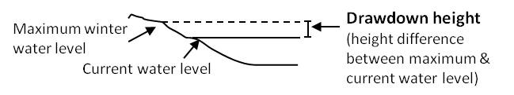  Imagine the pond as a clock face (with 12 o’clock as North). Take vegetation height at 2, 4, 6, 8, 10 and 12 o’clock.
Water left in the pond:
 |  |  | % of water area in pond relative to area at maximum water level
cm |  |  | Drawdown (see diagram) height drop from maximum water level
Grazing:
 |  |  |  | Tick if there is evidence the pond is grazed by livestock. If yes complete the following boxes:
% |  |  |  | % of whole pond grazed (note: that stock can wade into shallow ponds to graze)
% |  |  |  | % of pond perimeter grazed (note: stock can wade into shallow ponds to graze otherwise inaccessible edges)
 |  |  |  | Grazing intensity: rank 1-5 (1=infrequent or low intensity to 5 = margins heavily poached and almost bare)
Pond management (tick): use tick boxes to list management within the last 12 months. Use ‘other’ box for any extra info.
 | Fully dredged |  |  |  |  |  |  |  | Partly dredged |  |  |  |  | >5% vegetation removed |  |  |  |  |  | <5% vegetation removed
 | Trees planted |  |  |  |  |  |  |  | Trees clear-felled |  |  |  |  | Trees cut back / coppiced |  |  |  |  |  | Pond changed shape / size
 | Plants introduced |  |  |  |  |  |  |  | Bank plants mown |  |  |  |  | Structural work e.g. to dam |  |  |  |  |  | Straw added
Add other or more detail

Tubular Water-dropwort (Oenanthe fistulosa)

RARE SPECIES RECORDING FORM (PAGE 4 of 4)

PondNet

Turbidity / water clarity: Estimate turbidity looking down into c.20cm depth of water in the pond.
 |  |  |  | 1 = clear; 2 = moderately clear; 3 = moderately turbid; 4 = turbid
Inflows and outflows: (tick if inflow or outflow present or leave blank)
 | Inflow present |  |  |  |  |  |  |  |  |  |  | Outflow present
Water chemistry: If suitable kits and meters are available (or leave blank)
pH: Take 6 readings for pH from around the pond |  |  |  |  |  |  |  |  |  |  |  |  |  |  |  |  |  |  |  | Conductivity (μS cm⁻¹): Take 6 readings for conductivity
1 |  | 2 |  |  | 3 |  | 4 |  |  |  | 5 |  |  | 6 |  |  |  |  |  |  | 1 |  | 2 |  |  | 3 |  | 4 |  | 5 | 6
Nitrate (NO³⁻-N ppm): PPW kits provided by FHT  (tick one from the following range categories) |  |  |  |  |  |  |  |  |  |  |  |  |  |  |  |  |  |  |  | Phosphate (PO₄³⁻-P ppm): PPW kits provided by FHT  (tick one from the following range categories)
<0.2 |  | 0.2-0.5 |  |  | 0.5-1 |  | 1-2 |  |  |  | 2-5 |  |  | 5-10 |  | 10 + |  |  |  |  | <0.02 |  | 0.02-0.05 |  |  | 0.05-0.1 |  | 0.1-0.2 |  | 0.2-0.5 | 0.5-1 | 1 +
Pond base:
This refers to the geology (i.e. rock-type) that immediately underlies the pond. You may know, or be able to see the underlying geology in the base or banks of the pond, especially in new ponds. If not, check a geology map or leave this section blank.
Choose one of the following to categorise the % composition of each of pond base: 1= 0-32%, 2= 33-66%, 3= 67-100%
 | Silt/ clay |  |  |  |  |  |  | Sand, gravel, cobbles |  |  |  |  |  |  |  |  |  | Hard rock |  |  |  |  |  |  | Peat |  |  |  | Other (please specify)
Surrounding land use:
Estimate the percentage of surrounding land-use in distance zones from the pond perimeter (i.e. the maximum winter water level) used to assess pond area. In many ponds the 0-5m zone will include surrounding trees/scrub.
Habitat |  |  |  |  |  |  |  | 0-5m |  | 0-100m |  |  | Examples
Trees, woodland & scrub |  |  |  |  |  |  |  | % |  | % |  |  | Deciduous and coniferous woodland, individual trees, scrub and hedgerows.
Heath & moorland |  |  |  |  |  |  |  |  |  |  |  |  | Lowland and upland heathland, moorland and mountain; includes bracken.
Rank vegetation |  |  |  |  |  |  |  |  |  |  |  |  | Unmanaged grass, neglected and abandoned land, set-aside, verges and buffer strips.
Unimproved grassland |  |  |  |  |  |  |  |  |  |  |  |  | Herb-rich, calcareous and acid grassland (good quality plant indicators usually present). Low percentage of agricultural grasses. Not fertilised, little or no drainage.
Semi-improved grassland |  |  |  |  |  |  |  |  |  |  |  |  | A transition category. Grasslands modified by fertilisers, drainage, herbicides or intensive grazing, but retaining elements of natural grassland types in the area.
Improved grassland |  |  |  |  |  |  |  |  |  |  |  |  | Fertile agricultural grass, often bright green and lush; including parks and golf greens.
Arable |  |  |  |  |  |  |  |  |  |  |  |  | All crops. Includes flower and fruit crops (e.g. strawberries) and ploughed land.
Urban buildings & gardens |  |  |  |  |  |  |  |  |  |  |  |  | Areas in curtilage (associated with buildings); including glass-houses and farm yards.
Roads, tracks & paths |  |  |  |  |  |  |  |  |  |  |  |  | Including car-parks and footpaths.
Rock, stone & gravel |  |  |  |  |  |  |  |  |  |  |  |  | Cliffs, rock-outcrops, gravel-pits, quarries, areas of sand and gravel or stone.
Bog, fen, marsh & flush |  |  |  |  |  |  |  |  |  |  |  |  | Wetland vegetation and blanket bog.
Ponds & lakes |  |  |  |  |  |  |  |  |  |  |  |  | Permanent and seasonal waterbodies; including trackway pools.
Streams & ditches |  |  |  |  |  |  |  |  |  |  |  |  | Rivers, streams, ditches, springs and canals
Other (state) |  |  |  |  |  |  |  |  |  |  |  |  | E.g. maritime vegetation, saltmarsh, sand-dune, orchards and railways.
Is the pond in a protected area? (e.g. nature reserve, SSSI, etc)
(choose one option - yes, no, unknown)
New Zealand Pigmyweed Crassula helmsii: This non-native weed may have an impact on Tubular Water-dropwort.
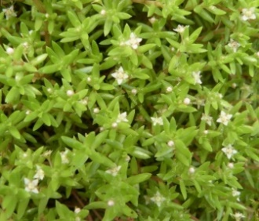
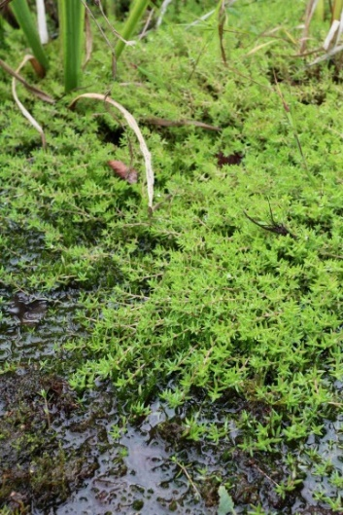
% of drawdown zone occupied by New Zealand Pigmyweed
Identification of New Zealand Pigmyweed:
- Can be submerged, emergent and terrestrial.
- Forms dense mats below and above the water surface.
- The flowers it has, if any at all, are very small (less than 1cm) whitish-green to slightly pink with 4 petals.
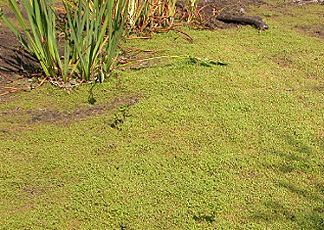
- Leaves are up to 2cm long in opposite pairs - fleshy for emergent plants, but flatter for submerged parts of the plant.
- Similar species (such as the Water-starworts) do not have fleshy leaves. Water-starworts also have a notch at the leaf tip which is absent in New Zealand Pigmyweed.

How much of pond perimeter could be surveyed? Note areas of pond not accessible.
Comments box: e.g. new ownership, changes since previous visit, any other information.

