Greater Water-parsnip (Sium latifolium)

RARE SPECIES RECORDING FORM (PAGE 1 of 4)
PondNet

METHOD
Aims: To find out if Greater Water-parsnip is i) present in the focal pond, ii) get an approximate idea of its location and abundance in the focal pond, iii) collect physical data about the focal pond that can be used to assess the reasons for any change recorded on future visits, and iv) look in any adjacent ponds to see if Greater Water-parsnip is present or absent.
- Equipment: It’s helpful to take a camera (e.g. mobile phone camera) to take confirmatory photos of Greater Water-parsnip, to take photos of your survey pond for the record, and to take a photograph of your sketch maps if you don’t have access to a scanner – alternatively you can give your survey forms to your regional officer.
- Survey timing: Greater Water-parsnip is quite a short-lived flowering plant and is best surveyed in July or August.
- Where to look: Greater Water-parsnip typically grows in the pond’s drawdown zone – the area that is wet in winter, but progressively dries out in summer. Plants can be found growing amongst long or short grass and other wetland plants, or along muddy margins - often just on the edge of the area poached by cattle, but just out of reach of grazing mouths. Search for it across all of the pond’s wet and dry marginal areas.
- Survey the pond: The Focal Pond will have a previous record for Greater Water-parsnip, although the plant may not have been recorded since the 1980s. Search the pond margins and shallow edges for Greater Water-parsnip plants, and if found, estimate the number of plants (see below). Draw a sketch map to show the location of Greater Water-parsnip within the focal pond – this may help you and others in the future to search the same area. Fill out the pond habitat survey form for the focal pond.
- How to estimate abundance: If Greater Water-parsnip plants are found in the focal pond, make an estimate of the number of plants present, and record the results as an abundance category (over page). It can be hard to count the number of plants, especially if they are closely growing or numerous. The best approach is to count the plants in a small area (e.g. 10 cm² or 1 m²), and multiply this by the area in which Greater Water-parsnip plants are found. If Greater Water-parsnip occurs in different areas or habitats in the pond, make separate calculations for each area, and sum them to give a total (see table over page). Note: we only need the overall total for the pond.
If Greater Water-parsnip is not found at the pond, please record this, and continue to fill out the pond habitat sheet and search other ponds in the surrounds. The findings will help identify reasons for the plant’s absence from the pond.

- Check other ponds and pools in the surrounds: Finding out if Greater Water-parsnip occurs in other nearby ponds helps us to understand if the species is part of a larger population, which may be important for its survival. Visit nearby ponds or pools to see if Greater Water-parsnip is present. You don’t need to record numbers, or environmental data at these other ponds.
It will be helpful to revisit these other ponds in future years. So, to ensure they can be found again by youself or others please (a) provide an accurate grid reference and/or mark the locations on your PondNet base map, or (b) make a sketch of the location of ponds around the focal pond and (c) take photos. Then, upload the maps and photos to the website.

What it looks like: Greater Water-parsnip is a very distinctive species, with key features that help to distinguish it from other umbellifers growing in the same habitat. It is a large robust plant (up to 200 cm), with hollow ridged green stems. These stems smell strongly of paraffin or petrol. The stem leaves are 1-pinnate, with large lanceolate leaflets which are finely toothed. The large umbels are held at the end of the plant stem.
The only species similar to Greater Water-parsnip is Lesser Water-parsnip. However, there are several differences which should rule out confusion. Lesser Water-parsnip has smaller plants (up to 100 cm) and more delicate, coarsely toothed leaflets. It is not as robust as Greater Water-parsnip and the stems do not smell strongly of paraffin.
We have produced a “Species Information Sheet” and “How to . . .” identification guide if you need some more hints and tips to recognise Greater Water-parsnip www.freshwaterhabitats.org.uk/projects/pondnet.
Once completed, enter your results online: www.freshwaterhabitats.org.uk/projects/waternet, or give your recording forms and maps to your regional project officer and we can enter data for you.

(c)
(b)
(a)

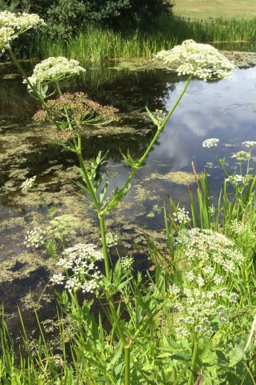
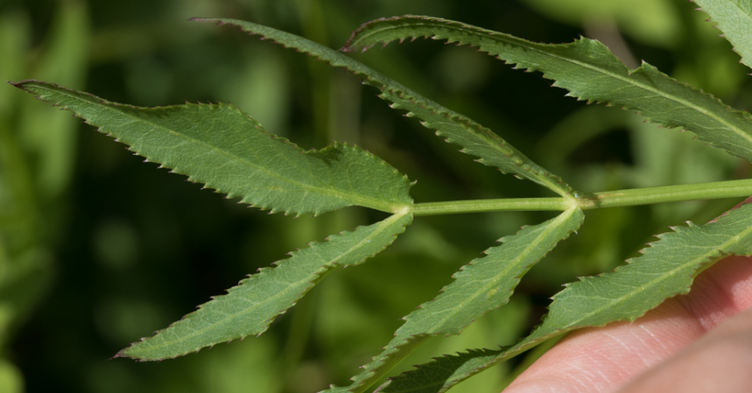
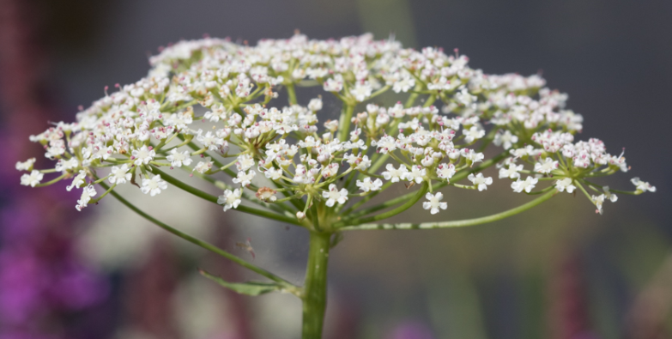
(c)
(a)
(b)

Greater Water-parsnip: (a) large umbel of white flowers, (b) characteristic stem leaflets which are lanceolata in shape finely toothed and, (c) Greater Water-parsnip growing along a pond margin in Surrey.

Greater Water-parsnip (Sium latifolium)

RARE SPECIES RECORDING FORM (PAGE 2 of 4)

PondNet

Your name |  |  |  | Date
Square: 4 figure grid ref  e.g. SP1243 (see your map) |  |  | Pond: 8 figure grid ref  e.g. SP 1235 4325 (see your map)
Focal Pond name
(if known)
Determiner name (optional - if someone confirms the identity of the species you’ve recorded) |  |  | Voucher material (optional - comment if you’ve taken a photo to confirm identification)

Number of Greater Water-parsnip in your Focal Pond
Record the number of Greater Water-parsnip plants found in the focal pond using the following categories:
1, 2-5, 6-10, 11-20, 21-50, 51-100, 101-200, 201-500, 501-1000, 1000+. If there are many plants, count the number in a small area and multiply up. We’ve put a table below to help you keep track and make notes, but for the analysis we only need a total.
If you find Greater Water-parsnip please take a confirmatory photo, especially if it’s the first time the pond has been surveyed for PondNet. You can also take a photo of your pond or your maps (or scan them if you have a scanner) and upload them with the record.
Pond habitat type or areas where the plant is found (list): use this table to help with your number calculations, and so you / others can re-find plants | Number of plants
1.
2.
3.
4.
Total number of Greater Water-parsnip plants (category)
Greater Water-parsnip looked for, but not found: (tick box if none found)
Note if you don’t find evidence of Greater Water-parsnip at the pond, this is an important result so please still enter these findings online
Species notes: Please add any views on pond condition for Greater Water-parsnip, and thoughts on why it may be abundant / declining / absent.

Sketch map: Use this box to show the location of Greater Water-parsnip plants in your focal pond. Use shading if they covered a broad area, or x marks the spot if there were just a few plants.

Search other ponds and pools in the surrounds

Please search other ponds or pools in the area to see if Greater Water-parsnip is present or absent. Then complete the following summary questions about the additional pond search.
To help re-find these other pools: (a) mark their locations on your PondNet base map (in your site information pack) and indicate whether Greater Water-parsnip was present or absent.

1. Was Greater Water-parsnip found in any additional ponds?

 | Yes |  | No (tick)

2. How many additional ponds did you search (if no other ponds were searched put a zero in both these boxes)?

Number of additional ponds with a positive record for Greater Water-parsnip.
Excluding the focal pond, how many other ponds had Greater Water-parsnip?
Number of additional ponds with a negative record for Greater Water-parsnip.
Excluding the focal pond, how many additional ponds did not have Greater Water-parsnip?

Greater Water-parsnip (Sium latifolium)

RARE SPECIES RECORDING FORM (PAGE 3 of 4)

PondNet

FOCAL POND HABITAT SURVEY:
This is a really important part of the survey at your focal pond. Please complete this Pond Habitat Survey for your focal pond, whether or not you find Greater Water-parsnip at the site.
Each variable provides information known to be linked to pond quality and community type, and can be used to investigate the reason for change in Greater Water-parsnip occurrence.

Is the pond new? (less than 10 yrs old)  yes, no, unknown |  |  |  |  |  |  |  | Year of creation?  date, decade, unknown |  |  |  |  | Pond Altitude (m)
Pond area |  |  |  | Note: This is the surface area of the pond when the water is at its highest level (usually in early spring). It will probably not be the current water level of the pond. The high water level line should be evident from wetland vegetation like rushes at the pond’s outer edge. Measure by pacing (single pace = 0.8-1m) or use online maps.
m²
Pond dries? |  |  |  |  |  | 1 = Never dries ,  2 = Rarely dries: no more than 2 years in any 10 year period, or only in drought,  3 = Sometimes dries: dries between three years in ten to most years,  4 = Dries annually. Deduce pond permanence from local knowledge (e.g. landowner) and personal judgement e.g. water level at the time of the survey. Ponds that dry out annually usually have a hard base.
1 = never dries
2 = rarely dries
3 = sometimes
4 = annually
Overhanging trees & shrubs |  |  |  |  |  |  |  |  |  | This is an estimate of how much of the pond is directly overhung by trees and shrubs, i.e. that would be shaded if the sun was overhead (use the diagram (below) as a guide).
% of pond overhung by trees and shrubs

% pond margin overhung to at least 1m out from the pond margin
Waterfowl impact |  |  |  |  | Major = severe impact of waterfowl e.g. few or no submerged plants, water turbid, pond banks have patches where vegetation removed, feed put down; Minor = waterfowl present, but little impact on pond vegetation, pond still supports submerged plants and banks are not denuded of vegetation; None = no evidence of waterfowl impact (moorhens may be present).
1 = major
2 = minor
3 = none
Fish presence |  |  |  |  | Major = dense populations of fish known to be present; Minor = small numbers of Crucian Carp, goldfish or stickleback known to be present; Possible = no evidence of fish, but local conditions suggest that they may be present; Absent = no records of fish stocking and no fish revealed during survey.
1 = major
2 = minor
3 = possible
4 = absent
Aquatic vegetation: includes emergent, floating and submerged plants |  |  |  |  |  |  |  |  |  |  | 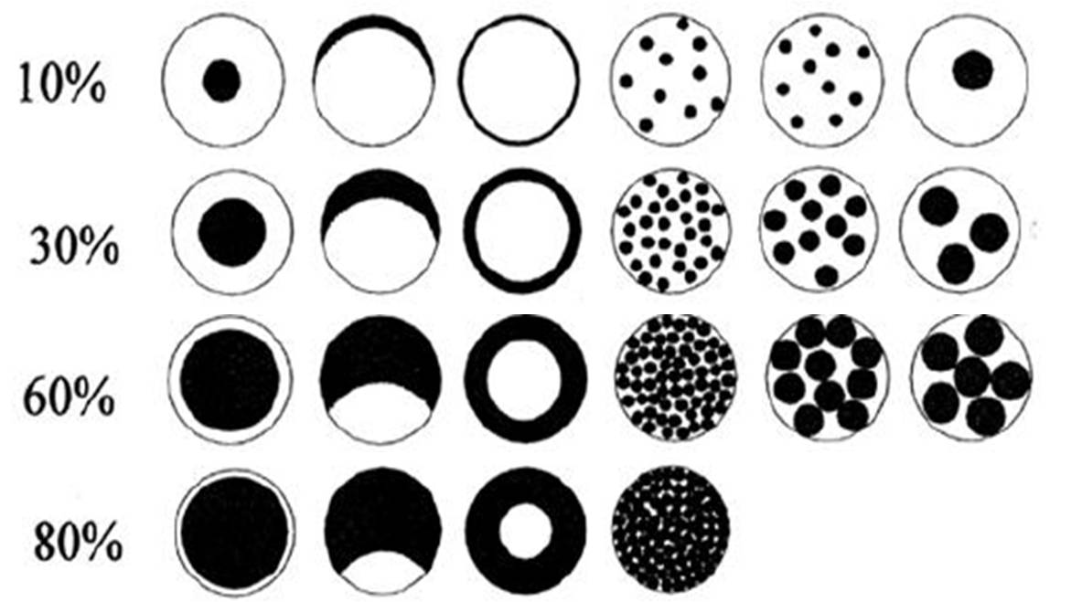
% |  |  | % of the whole pond (wet and dry) occupied by emergent vegetation – incl. plants like grasses, water mint and rushes, but not floating (e.g. duckweeds) or submerged (e.g. water-crowfoot) species - to see a list of emergent species look at the survey guide www.freshwaterhabitats.org.uk/projects/pondnet/survey-options/habitats
% |  |  | % of pond water surface area covered by all vegetation (emergent, floating (excl. duckweed) and submerged).
 |  |  |  |  |  |  |  |  | 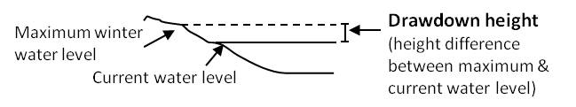
Water left in the pond
% |  |  | % of water area in pond relative to maximum water level – This can be 0% if the pond has dried out.
cm |  |  | Drawdown (height drop from maximum winter water level to current level).
Grazing
Tick if there is evidence the pond is grazed by livestock.
If yes complete the following boxes:
 | % | % of whole pond grazed (note: stock can wade into shallow ponds to graze).
 | % | % of pond perimeter grazed (note: stock can wade into shallow ponds to graze otherwise inaccessible edges).
 |  | Grazing intensity: rank 1-5 (1=infrequent or low intensity to 5 = margins heavily poached and almost bare).

Greater Water-parsnip (Sium latifolium)

RARE SPECIES RECORDING FORM (PAGE 4 of 4)

PondNet

Pond management (tick):
Use the tick boxes to list management within the last 12 months. Use ‘other’ box for any extra info.
 |  | Fully dredged |  |  |  |  |  |  |  |  |  | Partly dredged |  |  |  |  |  |  |  |  |  | >5% vegetation removed |  |  |  |  |  |  |  |  |  |  |  |  | <5% vegetation removed
 |  | Trees planted |  |  |  |  |  |  |  |  |  | Trees clear-felled |  |  |  |  |  |  |  |  |  | Trees cut back / coppiced |  |  |  |  |  |  |  |  |  |  |  |  | Pond changed shape / size
 |  | Plants introduced |  |  |  |  |  |  |  |  |  | Bank plants mown |  |  |  |  |  |  |  |  |  | Structural work e.g. to dam |  |  |  |  |  |  |  |  |  |  |  |  | Straw added
Add other or more detail
Turbidity / water clarity:
Estimate turbidity looking down into c.20cm depth of water in the pond.
 |  |  |  | 1 = clear; 2 = moderately clear; 3 = moderately turbid; 4 = turbid
Inflows and outflows: (tick if inflow or outflow present or leave blank)
 | Inflow present |  |  |  |  |  |  |  |  |  |  |  |  |  |  | Outflow present
Water chemistry:
If suitable kits and meters are available (or leave blank):
 |  |  |  |  | pH |  |  |  |  |  |  |  |  |  |  |  |  |  |  |  |  |  |  |  |  |  |  | Conductivity (μS cm⁻¹)
Nitrate (NO³⁻-N ppm): PPW kits provided by FHT  (tick one from the following range categories) |  |  |  |  |  |  |  |  |  |  |  |  |  |  |  |  |  |  |  |  |  |  |  |  | Phosphate (PO₄³⁻-P ppm): PPW kits provided by FHT  (tick one from the following range categories)
<0.2 |  |  | 0.2-0.5 |  |  | 0.5-1 |  |  |  | 1-2 |  |  |  |  | 2-5 |  |  | 5-10 | 10 + |  |  |  |  |  |  | <0.02 | 0.02-0.05 |  |  |  | 0.05-0.1 |  |  | 0.1-0.2 |  |  | 0.2-0.5 | 0.5-1 | 1 +
 |  |  |  |  |  |  |  |  |  |  | Nitrate (other kit - give kit name and unit of measurement) |  |  |  |  |  |  |  |  |  |  |  |  |  |  |  |  |  |  |  |  |  | Phosphate (other kit - give kit name and unit of measurement)
Pond base:
This refers to the geology (i.e. rock-type) that immediately underlies the pond. You may know, or be able to see the underlying geology in the base or banks of the pond, especially in new ponds. If not, check a geology map or leave this section blank.
Choose one of the following to categorise the % composition of each of pond base: 1= 0-32%, 2= 33-66%, 3= 67-100%
 | Silt/ clay |  |  |  |  |  |  |  |  |  | Sand, gravel, cobbles |  |  |  |  |  |  |  |  |  |  |  | Hard rock |  |  |  |  |  |  | Peat |  |  |  |  |  | Other (please specify)
Surrounding land use:
Estimate the percentage of surrounding land-use in distance zones from the pond perimeter (i.e. the maximum winter water level) used to assess pond area. In many ponds the 0-5m zone will include surrounding trees/scrub.
Habitat |  |  |  |  |  |  |  |  |  |  | 0-5m |  |  | 0-100m |  |  | Examples
Trees, woodland & scrub |  |  |  |  |  |  |  |  |  |  | % |  |  | % |  |  | Deciduous and coniferous woodland, individual trees, scrub and hedgerows.
Heath & moorland |  |  |  |  |  |  |  |  |  |  |  |  |  |  |  |  | Lowland and upland heathland, moorland and mountain; includes bracken.
Rank vegetation |  |  |  |  |  |  |  |  |  |  |  |  |  |  |  |  | Unmanaged grass, neglected and abandoned land, set-aside, verges and buffer strips.
Unimproved grassland |  |  |  |  |  |  |  |  |  |  |  |  |  |  |  |  | Herb-rich, calcareous and acid grassland (good quality plant indicators usually present). Low percentage of agricultural grasses. Not fertilised, little or no drainage.
Semi-improved grassland |  |  |  |  |  |  |  |  |  |  |  |  |  |  |  |  | A transition category. Grasslands modified by fertilisers, drainage, herbicides or intensive grazing, but retaining elements of natural grassland types in the area.
Improved grassland |  |  |  |  |  |  |  |  |  |  |  |  |  |  |  |  | Fertile agricultural grass, often bright green and lush; including parks and golf greens.
Arable |  |  |  |  |  |  |  |  |  |  |  |  |  |  |  |  | All crops. Includes flower and fruit crops (e.g. strawberries) and ploughed land.
Urban buildings & gardens |  |  |  |  |  |  |  |  |  |  |  |  |  |  |  |  | Areas in curtilage (associated with buildings); including glass-houses and farm yards.
Roads, tracks & paths |  |  |  |  |  |  |  |  |  |  |  |  |  |  |  |  | Including car-parks and footpaths.
Rock, stone & gravel |  |  |  |  |  |  |  |  |  |  |  |  |  |  |  |  | Cliffs, rock-outcrops, gravel-pits, quarries, areas of sand and gravel or stone.
Bog, fen, marsh & flush |  |  |  |  |  |  |  |  |  |  |  |  |  |  |  |  | Wetland vegetation and blanket bog.
Ponds & lakes |  |  |  |  |  |  |  |  |  |  |  |  |  |  |  |  | Permanent and seasonal waterbodies; including trackway pools.
Streams & ditches |  |  |  |  |  |  |  |  |  |  |  |  |  |  |  |  | Rivers, streams, ditches, springs and canals
Other (state) |  |  |  |  |  |  |  |  |  |  |  |  |  |  |  |  | E.g. maritime vegetation, saltmarsh, sand-dune, orchards and railways.
Is the pond in a protected area? (e.g. nature reserve, SSSI, etc)
(choose one option - yes, no, unknown)

How much of pond perimeter could be surveyed? Note areas of pond not accessible.
Comments box: e.g. new ownership, changes since previous visit, any other information.

