PondNet
Tubular Water-dropwort (Oenanthe fistulosa) &
Greater Water-parsnip (Sium latifolium)
RAPID SURVEY RECORDING FORM FOR NON POND HABITATS (PAGE 1 of 2)

Rapid survey recording form for Tubular Water-dropwort and Greater Water-parsnip
This is a simple rapid survey recording form to document the presence/absence of either Tubular Water-dropwort or Greater Water-parsnip from any wetland habitat. This rapid survey is targeted on non pond habitats such as ditches, rivers, fens, and wet meadows. We are attempting to revisit as many sites as possible where the species has previously been recorded, working with local and national recording schemes and Local Environmental Records Centres, to gather information on species distribution and status.

What if I find these species growing in a pond?
If you discover Tubular Water-dropwort or Greater Water-parsnip at a pond please complete a full PondNet survey using the Rare Species Recording forms: http://freshwaterhabitats.org.uk/projects/pondnet/survey-options.
PondNet is a national pond monitoring network which aims to gather environmental data alongside species abundance data to better understand the status of some of the UKs rarest species in pond habitats.
However, if you do not have time to complete a full survey, or you would like to confirm that you have correctly identified Tubular Water-dropwort or Greater Water-parsnip, you can use this form to quickly record either species from pond habitats. Freshwater Habitats Trust will then aim to follow-up these records with a full PondNet survey.

How to take part
- Get hints and tips on identification of these species overleaf, and at freshwaterhabitats.org.uk
- Undertake a visual search of your waterbody (ditch, river, fen, meadow or other). The ideal time to survey is June – August (September)
- Look for Tubular Water-dropwort and Greater Water-parsnip: Please record the habitat type and, if you have time, the number of plants seen.
- Draw a map: It will be helpful to revisit these sites in future years. So, to ensure they can be found again by yourself or others please provide an accurate grid reference and/or mark the locations on a base map.
- Please enter your results online at: http://freshwaterhabitats.org.uk/projects/pondnet/twd-gwp-2017 or return this form to your regional officer.
- Share photos of the Tubular Water-dropwort and Greater Water-parsnip and the habitats where you find them, to our Facebook page https://www.facebook.com/PeoplePondsWater or Twitter @pondriverstream.

ABOUT YOUR SEARCH (* essential information)

Surveyor name(s) *
(please list everyone who took part)
Date *  (dd/mm/yyyy) |  | Grid reference or postcode *  (see survey support material to find a grid reference)
Site name *
(please provide a reference location)
Email address (only required if you would like to sign up to the People, Ponds and Water mailing list)

WHAT DID YOU FIND?

 | Species seen?  (please tick) | Number of plants  (use abundance category below) | Habitat type  (e.g. fen, wet meadow, river, ditch, pond) | Size of area searched  (e.g. approx. length of bank or area of fen m²)
Tubular water-dropwort
(Oenanthe fistulosa)

Greater water-parsnip
(Sium latifolium)

Abundance categories:
1, 2-5, 6-10, 11-20, 21-50, 51-100, 101-200, 201-500, 501-1000, 1001-2000, 2001+
PondNet
Tubular Water-dropwort (Oenanthe fistulosa) &
Greater Water-parsnip (Sium latifolium)
RAPID SURVEY RECORDING FORM FOR NON POND HABITATS (PAGE 2 of 2)

TUBULAR WATER-DROPWORT (Oenanthe fistulosa)

- Survey timing: Tubular Water-dropwort is a late-growing plant and is best surveyed between July and September.
- Where to look: Tubular Water-dropwort typically grows in the drawdown zone – an area that is wet in winter, but progressively dries out in summer. Plants can be found growing amongst long or short grass and other wetland plants, or along muddy margins and in shallow water poached by animal’s hooves.
- What it looks like: Tubular Water-dropwort is a very variable species: it often occurs as small low-growing plants only a few cm high, with a rather cow-parsley-like basal leaf (basal leaves grow at the bottom of the stem) and may also have finely divided submerged leaves (see photo). It is easier to identify and record abundance once the plants reach maturity. The characteristic stem and stem leaves of Tubular Water-dropwort (see photo), typically develop when the plants are older. Mature, flowering, plants can be surprisingly tall: over 1m in height. Where they grow in amongst other tall wetland species, their stems are sometimes lax and scrambling, and they often fall over as the stems are quite weak. Later in the season, the flowers develop distinctive rounded fruiting heads.
(ci)
(c)
(b)
(a)
(a)

(cii)

Tubular Water-dropwort: (a) submerged leaves, (b) basal leaves and (c) flowering stem - the easiest stage to identify, with characteristic stem leaf (ci) and globular fruiting heads (cii).

GREATER WATER-PARSNIP (Sium latifolium)

- Survey timing: Greater Water-parsnip is quite a short-lived flowering plant and is best surveyed in July or August.
- Where to look: Greater Water-parsnip typically grows in the drawdown zone – an area that is wet in winter, but progressively dries out in summer. Plants can be found growing amongst long or short grass and other wetland plants, or along muddy margins - often just on the edge of the area poached by cattle, but just out of reach of grazing mouths.
- What it looks like: Greater Water-parsnip is a very distinctive species, with key features that help to distinguish it from other umbellifers growing in the same habitat. It is a large robust plant (up to 200cms), with hollow ridged green stems. These stems smell strongly of paraffin or petrol. The stem leaves are 1-pinnate, with large lanceolate leaflets which are finely toothed. The large umbels are held at the end of the plant stem. The only species similar to Great Water-parsnip is Lesser Water-parsnip. However, there are several differences which should rule out confusion. Lesser Water-parsnip has smaller plants (up to 100cm) and more delicate, coarsely toothed leaflets. It is not as robust as Greater Water-parsnip and the stems do not smell strongly of paraffin.
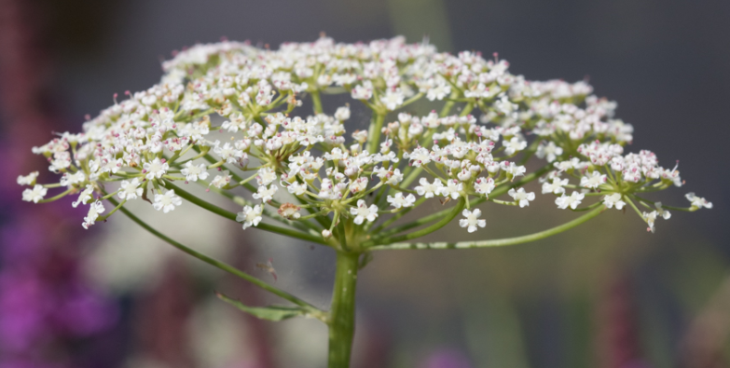
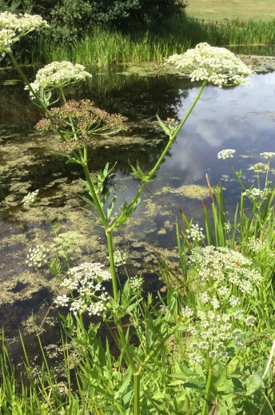
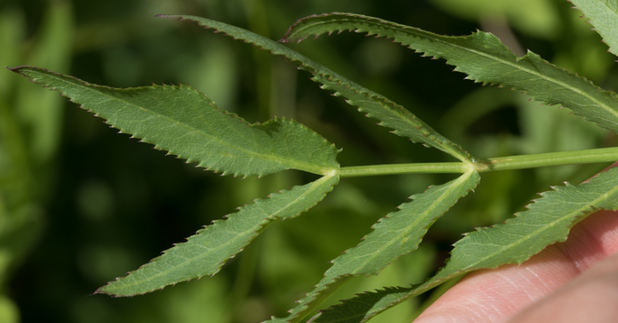
(c)c)
(b)
(a)
Great Water-parsnip: (a) large umbel of white flowers, (b) characteristic stem leaflets which are lanceolate in shape and finely toothed and, (c) Greater Water-parsnip growing along a pond margin in Surrey.

